UESTC November 19th 2013
SCHOOL OF INFORMATION AND COMMUNICATION ENGINEERING

Digital Signal Processing

Teacher: M^{r} Lin

Topic : Talk about filter specifications and how to design a digital filter based on the given specifications

Name | GHERAIB ABDELGHANI | Student ID | 201224010112



Digital Filter
Design and Specifications

Introduction
I. What is a Filter?
II. What is a Digital Filter?
III. Advantages of using digital filters
IV. What is digital filter design?
V. Specifications of design:

Introduction:
Signal Processing is an indispensable discipline that every engineer should know. The improvement of performance of systems over the last thirty years is due, in large part, to the application of signal processing techniques.
Digital Signal Processors (DSP) take real-world signals like voice, audio, video, temperature, pressure, or position that has been digitized, and then mathematically manipulates them. A DSP is designed for performing mathematical functions like "add", "subtract", "multiply" and "divide" very quickly.
One technique of the DSP domain is the digital filters; object of this modest paper.
I. What is a Filter?
Any medium through which the signal (sound for example) passes, whatever its form, can be regarded as a filter. However, we do not usually think of something as a filter unless it can modify the sound in some way. For example, speaker wire is not considered a filter, but the speaker is. The different vowel sounds in speech are produced primarily by changing the shape of the mouth cavity, which changes the resonances and hence the filtering characteristics of the vocal tract. The tone control circuit in an ordinary car radio is a filter, as are the bass, midrange, and treble boosts in a stereo preamplifier. Graphic equalizers, reverberators, echo devices, phase shifters, and speaker crossover networks are further examples of useful filters in audio. There are also examples of undesirable filtering, such as the uneven reinforcement of certain frequencies in a room with "bad acoustics". A well-known signal processing wizard is said to have remarked, "When you think about it, everything is a filter".

II. What is a Digital Filter?
Digital Filter: numerical procedure or algorithm that transforms a given sequence of numbers into a second sequence that has some more desirable properties. It is just a filter that operates on digital signals, such as sound represented inside a computer. It is a computation which takes one sequence of numbers (the input signal) and produces a new sequence of numbers (the filtered output signal).
The filters mentioned in the previous paragraph are not digital only because they operate on signals that are not digital. It is important to realize that a digital filter can do anything that a real-world filter can do. That is, all the filters alluded to above can be simulated to an arbitrary degree of precision digitally. Thus, a digital filter is only a formula for going from one digital signal to another. It may exist as an equation on paper, as a small loop in a computer subroutine, or as a handful of integrated circuit chips properly interconnected.
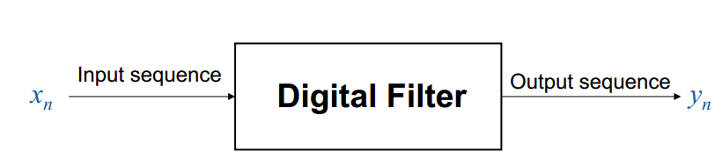

II.1. Desired features
Desired features depend on the application, for example:

Input Signal Output signal
Generated by sensing having less noise or interferences.
device (microphone)

Speech transmission. with reduced redundancy for more efficient.

II.2. Examples of filtering operations:
- received radio signals ;
- signals received by image sensors (TV, infrared imaging devices) ;
- electrical signals measured from human body (brain heart, neurological signals) ;
- signals recorded on analog media such as analog magnetic tapes.

III. Advantages of using digital filters
The following list gives some of the main advantages of digital over analog filters:
- A digital filter is programmable, i.e. its operation is determined by a program stored in the processor's memory. This means the digital filter can easily be changed without affecting the circuitry (hardware). An analog filter can only be changed by redesigning the filter circuit.

- Digital filters are easily designed, tested and implemented on a general-purpose computer or workstation.

- The characteristics of analog filter circuits (particularly those containing active components) are subject to drift and are dependent on temperature. Digital filters do not suffer from these problems, and so are extremely stable with respect both to time and temperature.

- Unlike their analog counterparts, digital filters can handle low frequency signals accurately. As the speed of DSP (digital signal processing) processors technology continues to increase, digital filters are being applied to high frequency signals in the RF (radio frequency) domain, which in the past was the exclusive preserve of analog technology.

- Digital filters are very much more versatile in their ability to process signals in a variety of ways; this includes the ability of some types of digital filter to adapt to changes in the characteristics of the signal.

- Fast DSP processors can handle complex combinations of filters in parallel or cascade (series), making the hardware requirements relatively simple and compact in comparison with the equivalent analog circuitry.

IV. What is digital filter design?
The design of a digital filter is carried out in three steps :

- Specifications: they are determined by the applications ;

- Approximations: once the specifications are defined, we use various concepts and mathematics that we studied so far to come up with a filter description that approximates the given set of specifications.

- Implementation: The product of the above step is a filter description in the form of either a difference equation, or a system function H(z), or an impulse response h(n). From this description we implement the filter in hardware or through software on a computer.

Digital filter design is the process of deriving
the transfer function G(z).

V. Specifications of design:
Usually, either the magnitude and/or the phase (delay) response are specified for the design of digital filter for most applications.
- Specifications are required in the frequency-domain in terms of the desired magnitude and phase response of the filter.

- Generally a linear phase response in the pass-band is desirable.

– In the case of FIR filters, It is possible to have exact linear phase ;
– In the case of IIR filters, a linear phase in the passband is not achievable ;
– Hence we will consider magnitude-only specifications.

V.1. Practical applications :
In most practical applications, the problem of interest is the development of a realizable approximation to a given magnitude response specification.
V.2. Goal of the paper :
I present in this paper only the magnitude approximation problem.
V.3. Types of filters :
There are four basic types of ideal filters with magnitude responses as shown below :

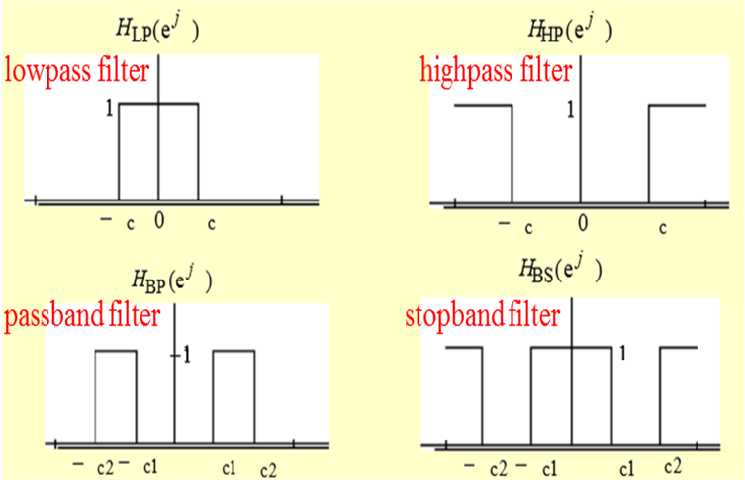
fig.1 : Types of filters.
- Since the impulse response corresponding to each of these ideal filters is noncausal, these filters are not realizable.
- In practice, the magnitude response specifications of a digital filter in the passband and in the stopband are given with some acceptable tolerances.
- In addition, a transition band is specified between the passband and stopband.
- For example, the magnitude response G(e^{jw}) of a digital lowpass filter may be given as indicated below :

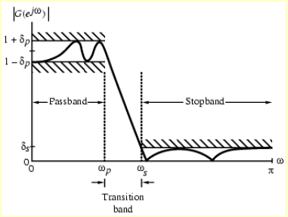
fig.2 : magnitude response G(e^{jw}) of a digital lowpass.

ωp : passband edge frequency ;
ωs : stopband edge frequency ;
δp : peak ripple value in the passband ;
δs : peak ripple value in the stopband.

- Since G(e^{jw}) is a periodic function of ω, and G(e^{jw}) of a real-coefficient digital filter is an even function of ω.
- As a result, filter specifications are given only for the frequency range 0 ≤ ω ≤ π.
- In practice, passband edge frequency F_{p} and stopband edge frequency F_{s} are specified in Hz.
For digital filter design, normalized bandedge frequencies need to be computed from specifications in Hz using :
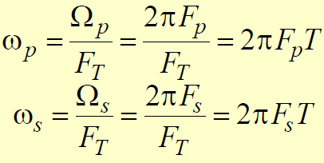

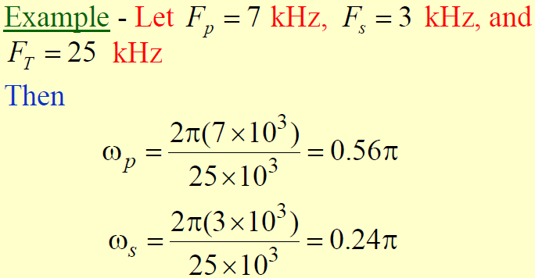
- The transfer function H(z) meeting the frequency response specifications should be a causal transfer function.

- For IIR (Infinite Impulse Response filter) digital filter design, the IIR transfer function is a real rational function of z⁻¹ :

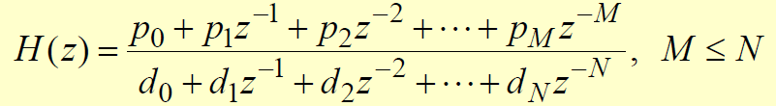

- H(z) must be a stable transfer function and must be of lowest order N for reduced computational complexity.

- For FIR (Finite Impulse Response filter) digital filter design, the FIR transfer function is a polynomial in z⁻¹ with real coefficients :

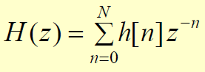

- For reduced computational complexity, degree N of H(z) must be as small as possible.

END

